Comparable Property Search
- Go to www.clinton.iowaassessors.com

- First select your sales search tab.

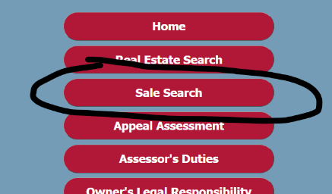

- Next is to fill in your search options. Remember sometimes less is better when filling out your search options. Start with the minimum and grow from that to find your more detailed search.

  - Sales Date Range – 1/1/2022 – 12/31/2022
  - Sales Amount Range – Recommend putting $1 in “Greater or Equal to”
  - Non-Usable Transaction Code – 0 – Normal Arm’s Length Transaction
  - Occupancy – Single Family / Owner Occupied
  - Style – Choose a comparable style of your home.
  - Central Air Conditioning – yes or no
  - Fireplace - Count
  - Basement Finish – Area of finished space.
  - Class – Default setting is Residential
  - Map Area – For County Res search only (i.e., Calamus Res, DeWitt Res or Andover Res)

- Then click on Display Results at the top of the page. IF “No Results Found” simply use your back button as instructed and verify all is correct and possibly simplify the search options.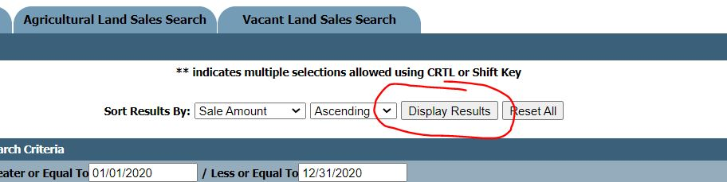
- Simply review the comparable sales and if you have further questions feel free to call or email our office. 563-244-0569 or assessor@clintoncounty-ia.gov Monday thru Friday 8 - 4:30

